Computational Physics Project 3 – Updated!

Random Walks and Ising Models

Roy Rinberg

**4.3 random walks**

Random walks are a pretty simple model to make:

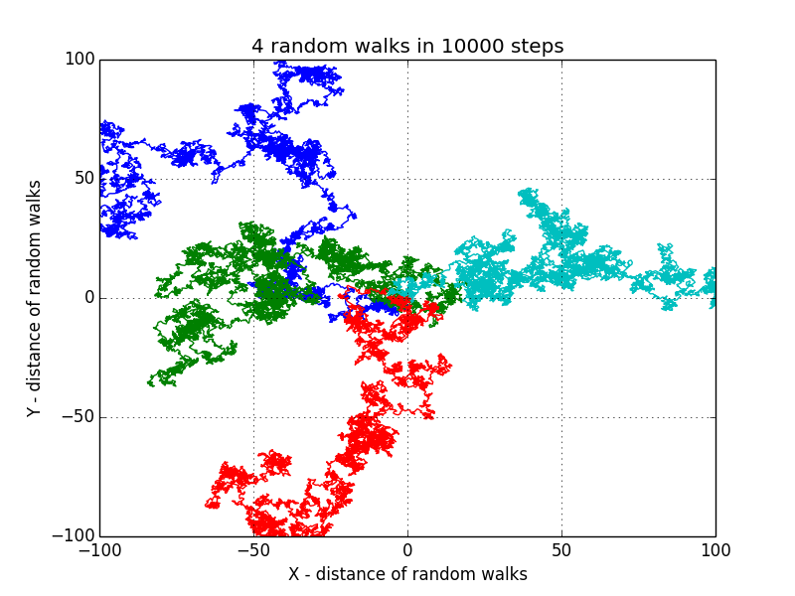

Essentially this takes a random walk for 1000 steps – the standard deviation of a random walk grows as $√N$ and nearly the entire plot is contained within a circle with radius of 100 (3 standard deviations away).

**4.5 modelling radioactive decay**

**4.6 modelling radioactive decay**

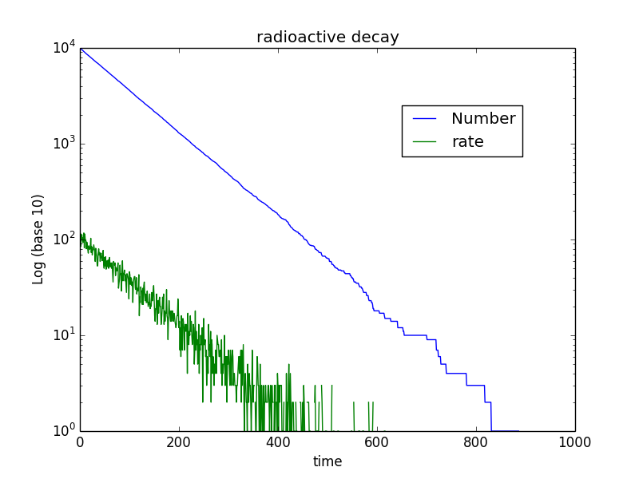

Here is a semi-log plot of radioactive decay, where we have superimposed the plots of the rate of decay (R = -a N(t) ) versus the number (N(t) = No – a N(t-1) )

As you can see, they generally mirror each other and have the same slope (as they should).

Note the difference between a real radioactive decay, and a continuous function, namely in the more noticeable discretizations when the count of N grows low.

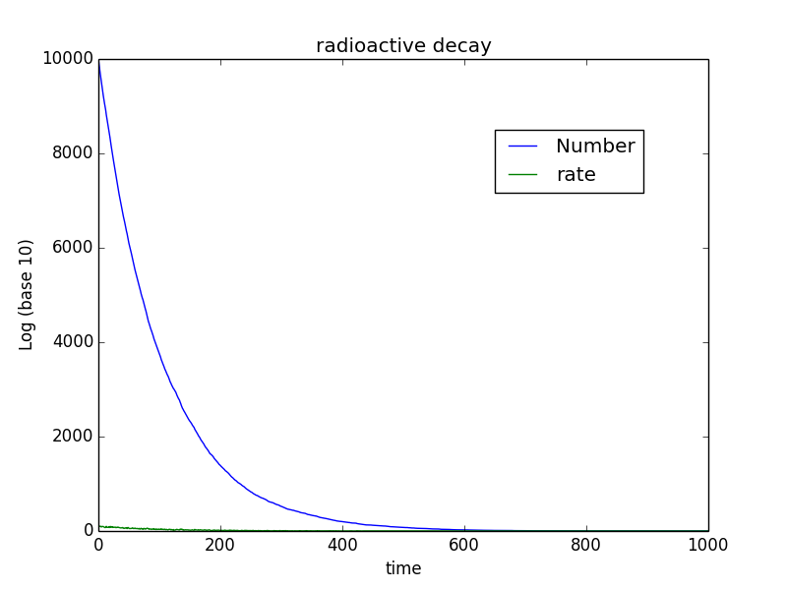

17.4 Metropolis

I made my own metropolis implementation of the 1-D ising model

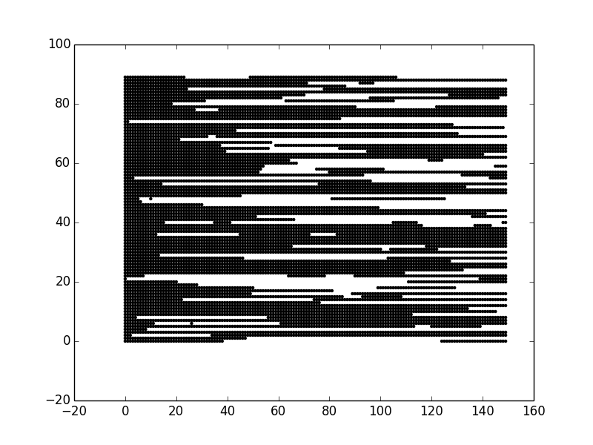

Here is a plot of the standard numbers plugged in (from the text), for 100 time steps. Metropolis algorithm seems odd, in that it looks for local minima by changing one term (in a discrete set) at a time, and so it seems intrinsically slow.

Metropolis works by changing 1 term, evaluating energy, and then if it is lower, then going down that path, otherwise keeping the old arrangement with some probability (as a function of temperature).

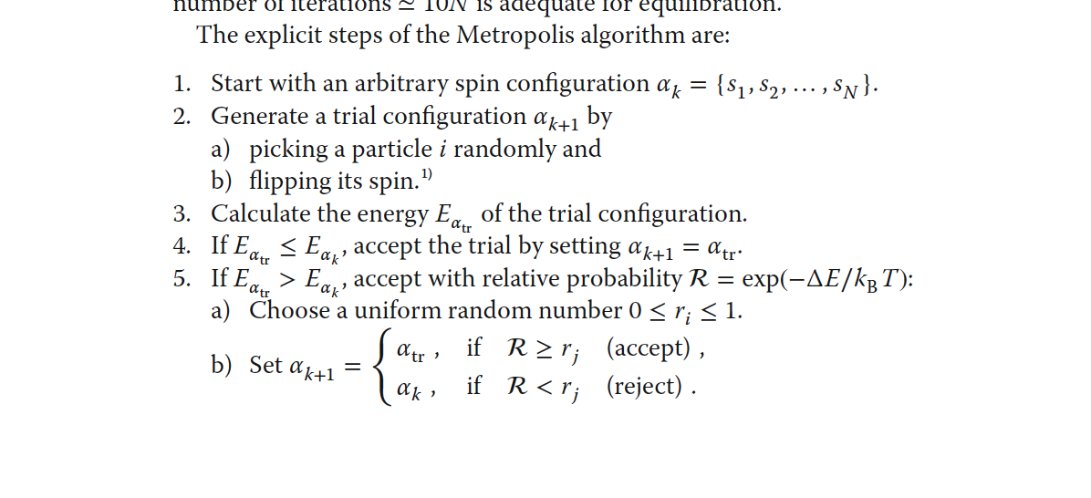

I am confident that there have to be better algorithms to calculate local minima, but I don’t know what they are.

Here is a plot of the average group size versus temperature – it looks exponential, and this aligns with what I would expect.

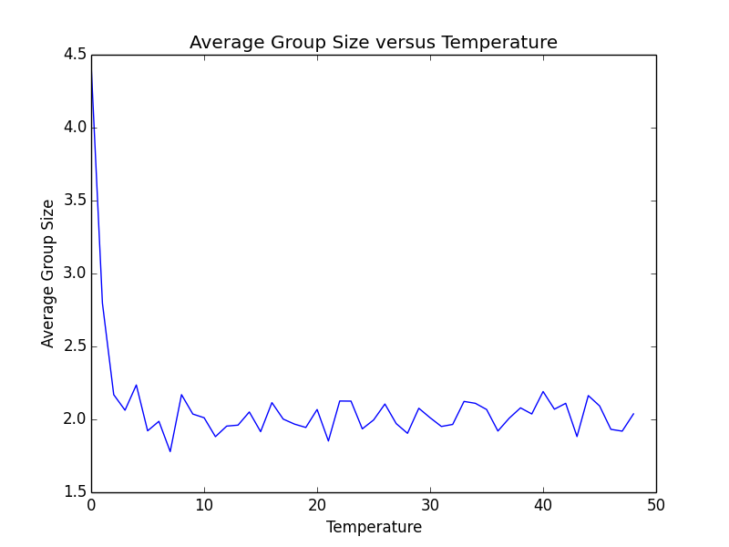

6. Make a plot of the internal energy U as a function of kBT and compare it to the analytic result (17.7).

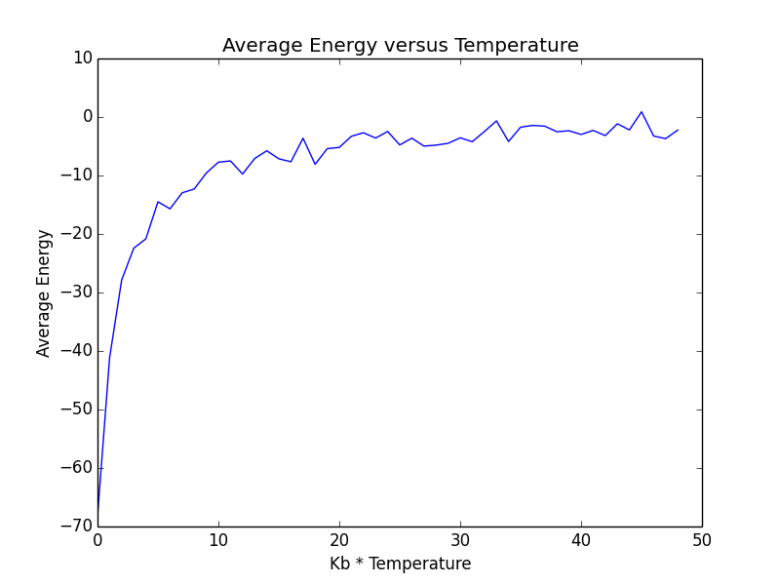

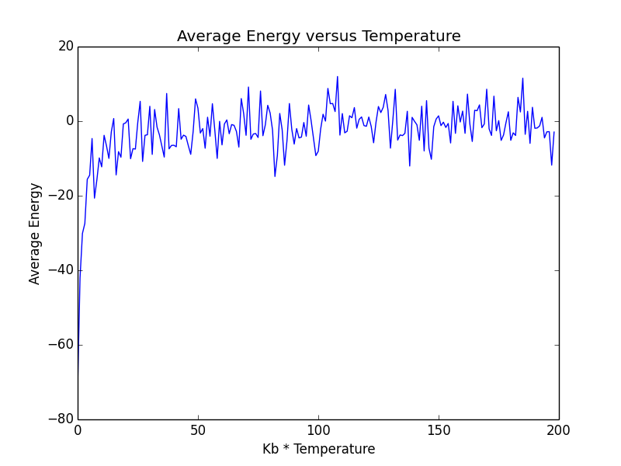

These two plots of energy versus temperature match the analytic function very well – and do so even better on larger time scales.

7. Make a plot of the magnetization as a function of kBT and compare it to the analytic result. Does this agree with how you expect a heated magnet to behave?

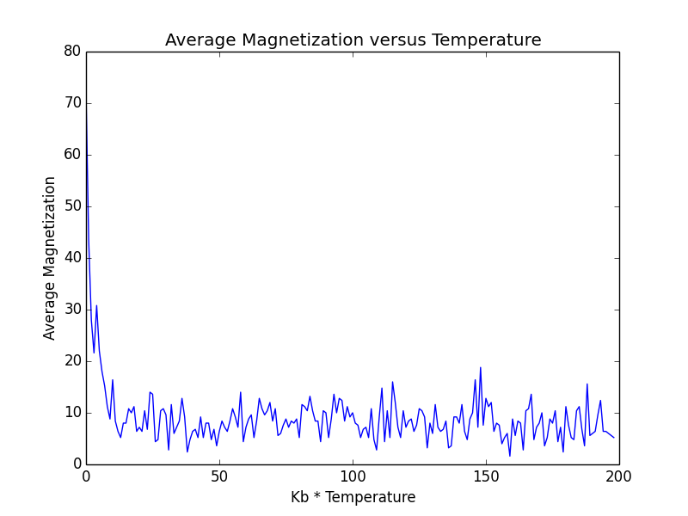

This looks very similar to the plot they showed of the Magnetization vs Temperature on page 419.

8. Compute the energy fluctuations U2 (17.17) and the specific heat C (17.18).Compare the simulated specific heat to the analytic result (17.8).

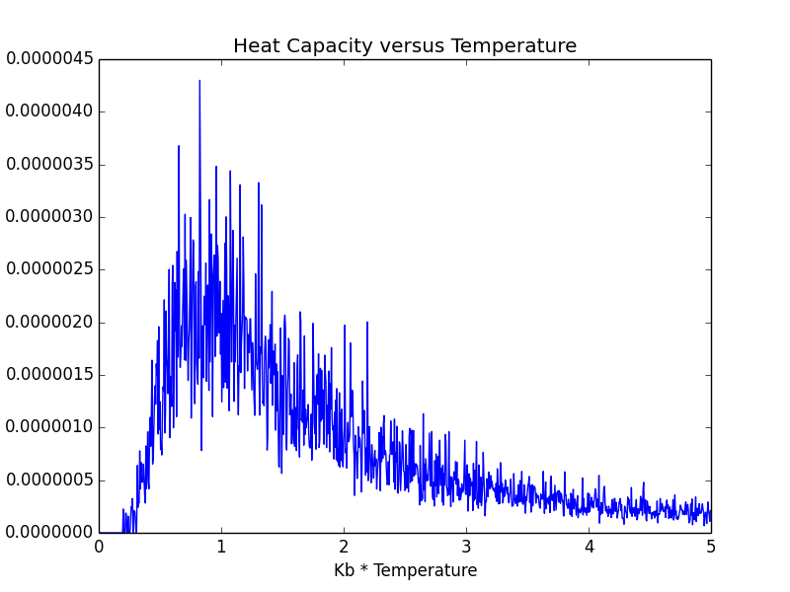

This is the plot of the heat capacity versus temperature (I think the scale on the Y axis may be off, but the shape is correct). This plot took me a long time to be able to get accurately, because I was originally getting the following plot:

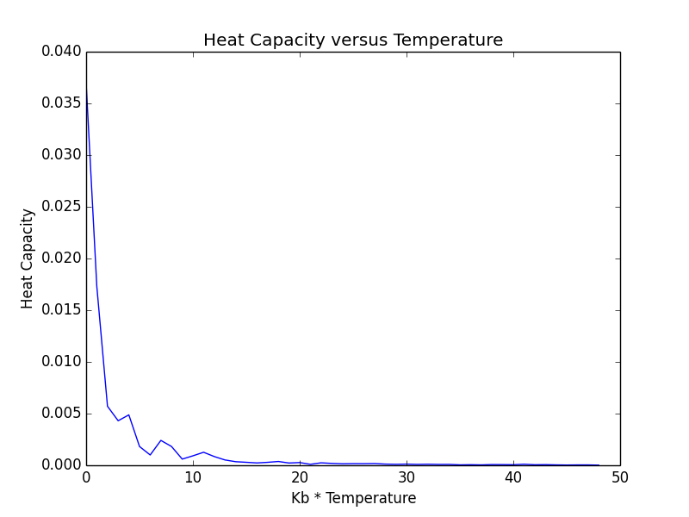

This is because I was essentially take a discrete derivative of the Energy as a function of temperature, but the dt of kB*T was actually larger than the evaluation for the energy, so it calculated that the derivative at the lowest energy was positive, instead of 0 (due to the fact that there is discrete number of particles that have energy, and so there is a region of 0<t < T, where the Energy does not change (it is locked in the lowest state). So the continuous derivative must start at 0.